Michael McKean

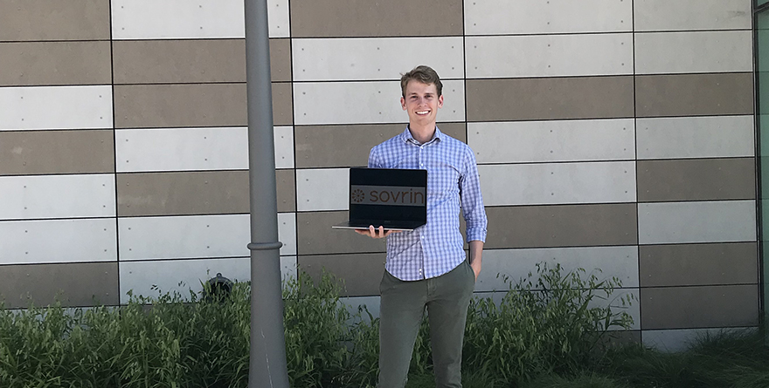

It’s time for another intern spotlight! And this time, we’re taking a quick jaunt over to the Harold B. Lee Library to sit down with Michael McKean, a first year MISM student interning for Sovrin Foundations.

Sovrin is a nonprofit organization that enables the creation and communication of online identifiers. Any website on which you create a profile or order anything requires certain identifiers from you. You have no control over what personal information you choose to give. Sovrin’s technology, the Sovrin Ledger, enables users to instead own their personal identifiers, such as their birthdate, certificate of graduation, etc. Users then can choose which pieces of information to share with online companies, much like how they would use driver’s licenses in real-world interactions – an identifier that they own and can provide a business upon request. By providing and protecting these “self-sovereign” identifiers, Sovrin allows people to build online relationships that resemble real-life ones.

Usually when we think of someone issuing IDs, we think of a shady rendezvous with a middle man in a dark alley or inconspicuous restaurant booth. The middle man has to report back to his employer with the client’s requests to spur the documentation. Michael is basically that middle man, coordinating communications between consumers and Sovrin developers, except the IDs are legitimate and everything is legal. Michael works as a community architect at Sovrin. He studies the company’s code base and then connects consumers with the identity developers. His knowledge of the code helps him communicate with consumers and understand what they need from their digital identities. He then helps the developers find the right place in the code to create what they need and document the work in progress.

Sitting in the library for hours each day normally wouldn’t sound too exciting to most people. But for Michael, it’s an opportunity to learn and create. “I was drawn to Information Systems the moment I realized it merged logic and creation,” Michael says. “It was almost magical.” He wants to use his IS skills and creativity to one day create something others value, something that makes a real impact.

Though he’s not exactly sure what that creation will be yet, he feels prepared for the challenge because of his experience in the IS core. “It taught me how to learn quickly and adapt to new situations.” Michael says, “The core classes teach technical skills that are applicable to my specific work at Sovrin, but it’s the soft skills that make the difference. They apply universally to any job or career.”

His ability to learn and try new things also impacts Michael’s passion for cooking. “I’m not intimidated by new recipes or techniques anymore because I know how to learn and research,” he says. “It’s basically coding for food!”

He encourages new IS students to be willing to invest their own time into their futures. “If you know where you want to go outside of school, put everything into it, including time outside of school. Really push yourself to learn and develop what you want.” Whether it’s a specific job or a favorite hobby you’re passionate about, the skills you learn at school can help you to succeed. It just takes the creativity and determination to put them to work.